CALIFORNIA TUMOR TISSUE REGISTRY
CME
SAMs
145th Semi-Annual Cancer Seminar

“Genitourinary Pathology: Practical Approaches to Differential Diagnosis”
Sunday, December 2, 2018
8:30 a.m. – 4:45 p.m.

Hyatt Regency Hotel at Embarcadero Center

5 Embarcadero Center
San Francisco, California, 94111
Phone: (415) 788-1234

Online: https://book.passkey.com/go/2018CSP Cut-Off Date: Once room block has been filled or by November 5, 2018

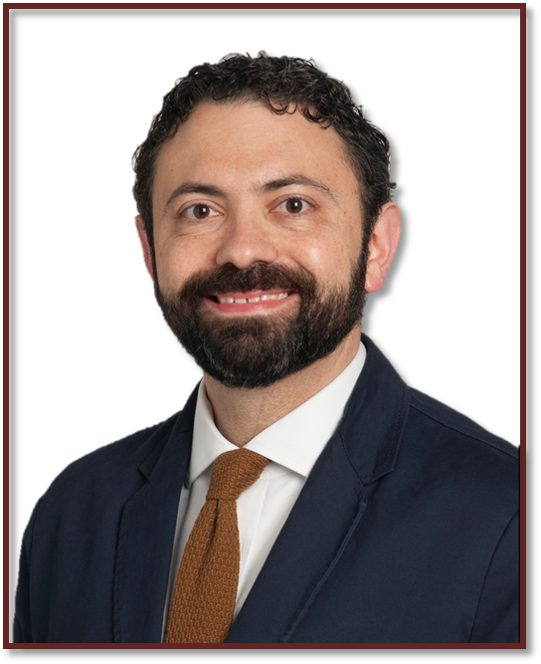
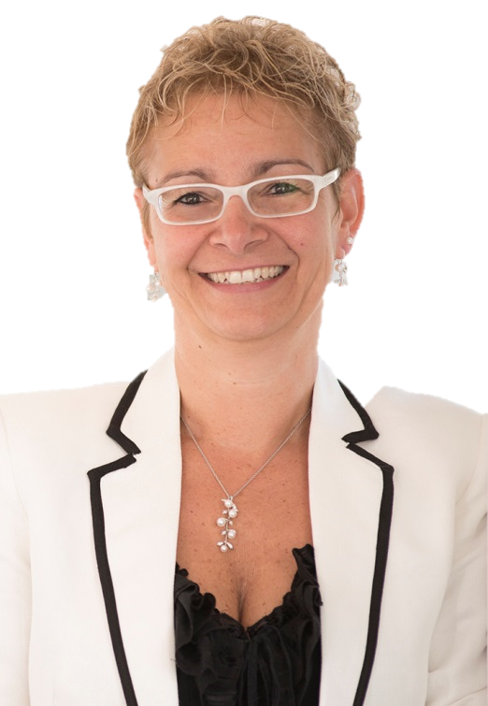

Christopher Przybycin, M.D.
Cleveland Clinic,
Cleveland, OH

Cristina Magi-Galluzzi, M.D.
Cleveland Clinic,
Cleveland, OH

Seminar Objectives: At the conclusion of this seminar, attendees will be able to:
- How to reliably differentiate testicular germ cell tumors from mimics
- Gain familiarity with common and uncommon diagnostic pitfalls in bladder pathology
- Recognize renal tumors with a hereditary basis and their unique clinical and familial implications
- Discuss histologic features and differential diagnosis of common challenging prostate lesions
CME/SAMs applies only on the day of the seminar. Full Package can earn up to 10 hrs of CME and/or SAMs credit, Attendance only can earn up to 6 hrs CME and/or SAMs credit. This activity is approved for a maximum of 10 SAM credits.

Accreditation Statement: This activity has been planned and implemented in accordance with the accreditation requirements and policies of the Accreditation Council for Continuing Medical Education (ACCME) through the joint providership of Loma Linda University School of Medicine and California Tumor Tissue Registry. The Loma Linda University School of Medicine is accredited by the ACCME to provide continuing medical education for physicians. The Loma Linda University School of Medicine designates this Live Activity and Enduring Materials for a maximum of 10 AMA PRA Category 1 Credit(s)TM. Physicians should claim only the credit commensurate with the extent of their participation in the activity.

ORDER FORM ON THE BACK ⇒

California Tumor Tissue Registry

Sunday, December 2, 2018
REGISTRATION FORM

Materials: (“Attendance Only” includes items 1 and 2)
1. 6 hour lecture (Seminar objectives, clinical histories, discuss the role of special studies in diagnosis, therapy,
and counseling, project photographs of study cases and other illustrative materials)
2. Comprehensive syllabus that includes diagnoses, discussion, and appropriate references from pertinent medical literature
3. Glass slides of representative tumors

CME/SAMs applies only on the day of the seminar. Full Package can earn up to 10.0 CME and/or SAM credits, Attendance only can earn up to 6 .0 CME and/or SAM credits. This activity is approved for a maximum of 10 SAM credits. Accreditation Statement: This activity has been planned and implemented in accordance with the accreditation requirements and policies of the Accreditation Council for Continuing Medical Education (ACCME) through the joint providership of Loma Linda University School of Medicine and California Tumor Tissue Registry. The Loma Linda University School of Medicine is accredited by the ACCME to provide continuing medical education for physicians. The Loma Linda University School of Medicine designates this Live Activity and Enduring Materials for a maximum of 10 AMA PRA Category 1 Credit(s)TM. Physicians should claim only the credit commensurate with the extent of their participation in the activity.
Disclosure Statement: This program has been planned and implemented in accordance with ACCME essentials and standards. The Loma Linda University School of Medicine Office of Continuing Medical Education relies on its CME faculty to provide program content that is free of commercial bias. Therefore, in accordance with ACCME standards, any faculty and/or provider industry relationships will be disclosed and resolved.
ATTENDEE INFORMATION

Name: Phone:

Facility: Email:

Mailing Address:
EARLY BIRD REGISTER
REGISTRATION FEE REGISTRATION AFTER 11/1/18
(Register by 11/1/18)
*Includes continental breakfast and drinks during breaks.

FULL PACKAGE - Up to 10 CME/ SAMs credit $350 $400
Includes: Glass slides and/or digital slides, Attendance and Syllabus
**Must attend the seminar and send in the answers before 12/2/18 for full CME/SAMs credit
Some case images maybe on a CD, I prefer a USB instead, add $5.00 for USB Yes add $5.00 Yes add $5.00

FULL PACKAGE - No CME/ SAMs credit $300 $350
Includes: Glass slides and/or digital slides, Attendance and Syllabus
Some case images maybe on a CD, I prefer a USB instead, add $5.00 for USB Yes add $5.00 Yes add $5.00

RESIDENT PACKAGE- No CME/ SAMs credit $225 $300
Includes: Glass slides and/or digital slides, Attendance and Syllabus
Some case images maybe on a CD, I prefer a USB instead, add $5.00 for USB Yes add $5.00 Yes add $5.00

ATTENDANCE ONLY- Up to 6 CME/SAMs credit…………………………………… $275 $300
Includes – Attendance, Syllabus

ATTENDANCE ONLY- No CME/SAMs credit ………………………………………. $225 $250
Includes – Attendance, Syllabus

RESIDENT ATTENDANCE ONLY- No CME/SAMs credit………………………… $175 $175
Includes – Attendance, Syllabus

Payment Information – Make Checks Payable to California Tumor Tissue Registry

Check enclosed Credit Card Master Card Visa

Credit Card # _____________________________________________ Exp. Date: ______________________________________________

Zip code of billing address: ________________ Total Amount: _______________For orders outside the United States of America, please add $40.00

Name on Card: __________________________________________________________________________________________________________

Signature: _______________________________________________________________________________________________________________

Cancellations subject to a 15% overhead charge. MAIL TO: Loma Linda University Pathology Medical Group Or FAX TO: (909) 558-0188
California Tumor Tissue Registry
11021 Campus Ave, AH335
www.CTTR.org PHONE: 909-558-4788 Loma Linda, CA 92350

