
CALIFORNIA TUMOR TISSUE REGISTRY
Proudly Announces the 146th Semi-Annual Pathology Cancer Seminar:
“Interesting Cases in Soft Tissue
and Dermatopathology”

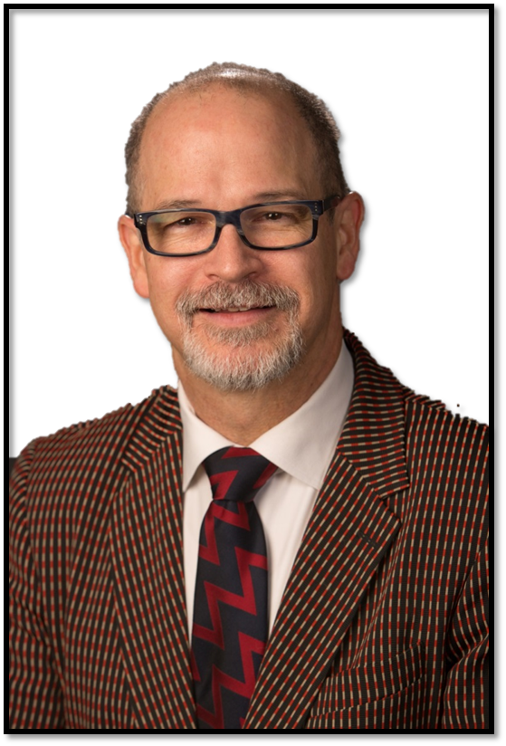


Sunday, June 2, 2019
8:30 am - 4:45pm

The Westin Hotel South Coast Plaza

686 Anton Boulevard
Costa Mesa, CA 92626
Phone: (714) 540-2500

DISCLOSURE STATEMENT: This program has been planned and implemented in accordance with ACCME essentials and standards. The Loma Linda University School of Medicine Office of Continuing Medical Education relies on its CME faculty to provide program content that is free of commercial bias. Therefore, in accordance with ACCME standards, any faculty and/or provider industry relationships will be disclosed and resolved.
Seminar Objectives: At the conclusion of this seminar, attendees will be able to:
- Learn and apply diagnostic criteria in the evaluation of cutaneous soft tissue tumors.
- Learn and apply diagnostic criteria in the evaluation of deep soft tissue tumors.
- Apply ancillary diagnostic studies in a cost effective manner in the evaluation of cutaneous and deep soft tissue tumors.

Materials: (“Attendance Only” includes items 1 and 2)
1. 6 hour lecture (Cover seminar objectives, correlate clinical histories, discuss the role of special studies in diagnosis, therapy,
and counseling, and project photographs of the study cases and other illustrative materials)
2. Comprehensive syllabus that includes diagnoses, discussion, and appropriate references from pertinent medical literature
3. Glass slides of representative tumors (Full package only)

CME/SAMs applies only on the day of the seminar. Full Package can earn up to 10 hrs CME and/or SAM, Attendance only can earn up to 6 hrs CME/SAM. This activity is approved for a maximum of 10 SAM credits. Accreditation Statement: This activity has been planned and implemented in accordance with the accreditation requirements and policies of the Accreditation Council for Continuing Medical Education (ACCME) through the joint providership of Loma Linda University School of Medicine and California Tumor Tissue Registry. The Loma Linda University School of Medicine is accredited by the ACCME to provide continuing medical education for physicians. The Loma Linda University School of Medicine designates this Live Activity for a maximum of 6.0 AMA PRA Category 1 Credit(s)TM. Physicians should claim only the credit commensurate with the extent of their participation in the activity.
The Loma Linda University School of Medicine designates this Enduring Material for a maximum of 4.0 AMA PRA Category 1 Credit(s)TM. Physicians should claim only the credit commensurate with the extent of their participation in the activity.
REGISTRATION FEE | Early Bird by 4/12/19 | After 4/12/19
Full Package: Up to 10 CME/SAMs credit ………………………………………………….  Includes: Glass slides, Attendance & Syllabus. Up to 4 CME/SAM credits for Glass slides. Turn in the Post-test that come with the slides before June 1, 2019 to earn credit. Up to 6 CME/SAM for attending the seminar. (Must complete the seminar pre and post-test to claim 6 SAM credits) | $350.00 | $400.00
Full Package: NO CME/SAMs credit ………………………………………………………….  Includes: Glass slides, Attendance & Syllabus. | $300.00 | $350.00
Resident Package: NO CME/SAMs credit ……………………………………………………..  Includes: Glass Slides, Attendance & Syllabus. ** With a letter verifying residency/fellowship status | $225.00 | $300.00
Attendance Only: Up to 6 CME/SAMs credit ………………………………………………….  Includes: Attendance & Syllabus. | $275.00 | $300.00
Attendance Only: NO CME/SAMs credit ……………………………………………………..  Includes: Attendance & Syllabus. | $225.00 | $250.00
Resident Attendance Only: NO CME/SAMs credit ……………………………………………  Includes: Attendance & Syllabus. **With a letter verifying residency/fellowship status | $175.00 | $175.00
+ Cancellations subject to a 15% overhead charge * For orders outside the United States of America, please add $45.00
Registration Form: (complete & mail, fax, or call CTTR) Please Circle: Check(mail) Visa Mastercard
Name: Name on Card:
Facility
Address: Credit Card Number: Call us to provide your card number
City, State, Country: Expiration Date: Zip code of billing address:
Zip: Phone:
Email: Total Amount:
Signature for Credit Card Authorization:
Mail Registration Form To: California Tumor Tissue Registry, 11021 Campus Street, AH 335, Loma Linda, CA 92350
Phone: (909) 558-4788 / Fax: (909) 558-0188 email: cttr@llu.edu

