
CALIFORNIA TUMOR TISSUE REGISTRY
11021 Campus Avenue, AH 335, Loma Linda, CA 92350
(909) 558-4788; Fax (909) 558-0188
CTTR@linkline.com

Proudly announces its upcoming 134th Semi-Annual Cancer Seminar:

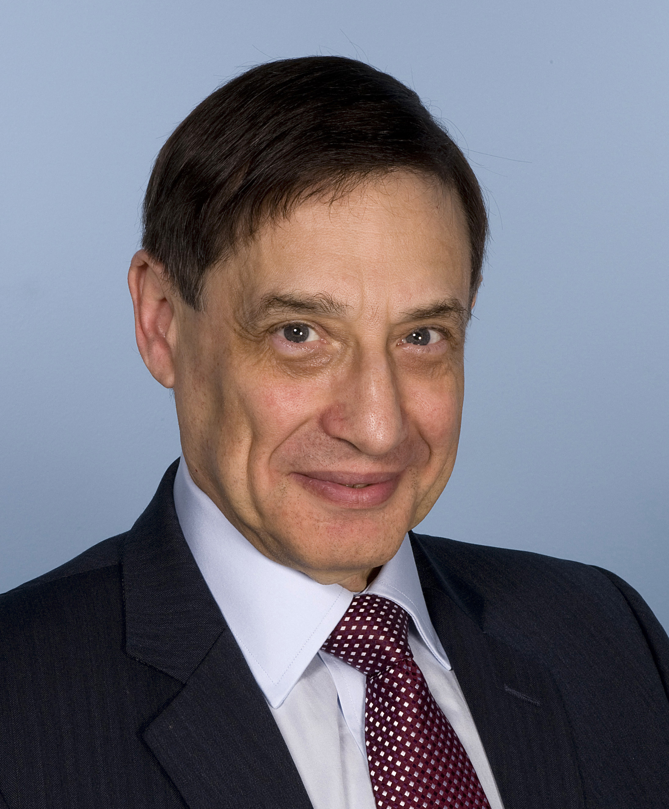
“Soft Tissue Tumors; Morphologic Challenges and Contemporary Approaches to Diagnosis”

December 8, 2013
8:30 a.m. - 4:45 p.m.

Hyatt Regency San Francisco

5 Embarcadero Center

San Francisco, California, 94111
Voice: (415) 788-1234

FREE
SAM’s
(Self-Assessment Module)
AVAILABLE

Cyril Fisher, M.D, DSc, FRCPath
Professor of Tumor Pathology and Consultant Histopathologist
University of London

Seminar Objectives: At the conclusion of this seminar, attendees will be able to:
- Recognize the morphologic features of a wide variety of soft tissue sarcomas, pseudosarcomas and tumor-like lesions and their differential diagnosis in core biopsy and excision specimens.
- Appropriately select and interpret immunohistochemical panels and molecular techniques to discriminate between morphologically similar soft tissue tumor types.
- Correlate clinical and pathologic findings for diagnosis, prognosis and management of soft tissue sarcomas.

Materials: 1. Glass slides representative of soft tissue tumors and tumor-like lesions. 2. Correlating clinical histories. 3. Six hour lecture, incorporating projected photographs of the study cases and other illustrative materials. 4. Comprehensive printed color syllabus, including diagnoses, discussion, and appropriate references from pertinent medical literature. CME and/or SAM credit applies only to the day of the seminar. Full Package can earn up to 10 hrs CME and/or SAM, Attendance only can earn up to 6 hrs CME and/or SAM. This activity is approved for a maximum of 10 SAM credits.

PRACTICING PATHOLOGIST |  | RESIDENCY TEACHING PROGRAM |  | RETIRED PATHOLOGIST |  | RESIDENT / FELLOW
Current Subscribing Member, Full Package. | $350.00 | Full Package. | $260.00 | Full Package. | $240.00 | Full package. | $210.00
Non-Subscribing Member, Full package. | $370.00 | Attendance Only. | $230.00 | Attendance Only.  . | $220.00 | Residents may attend the seminar free of charge with a letter verifying residency status. Syllabus included. | FREE
Attendance Only. | $230.00 | ** For orders  Outside the U.S.  please add $40.00 |  | + Cancellations subject to a 15% overhead charge

Registration Form: (complete, mail or fax) (Call CTTR with information if you wish)
Name: Please Circle: Check Visa Master Card
Facility: Name on Card:
Address: Credit Card number
P.O. Box: Expiration Date
City, State: Zip code of the billing address:
Zip: Phone: First four numbers of credit card billing address:
Fax:

Signature for Credit Card Authorization:

ACCREDITATION STATEMENT
Loma Linda University School of Medicine is accredited by the Accreditation Council for Continuing Medical Education (ACCME) to provide continuing medical education for physicians. Loma Linda University School of Medicine designates this Live Activity and Enduring Materials for a maximum of 10 AMA PRA Category 1 Credit(s) TM. Physicians should claim only the credit commensurate with the extent of their participation in the activity.

DISCLOSURE STATEMENT
This program has been planned and implemented in accordance with ACCME essentials and standards. The Loma Linda University School of Medicine Office of Continuing Medical Education relies on its CME faculty to provide program content that is free of commercial bias. Therefore, in accordance with ACCME standards, any faculty and/or provider industry relationships will be disclosed and resolved.

