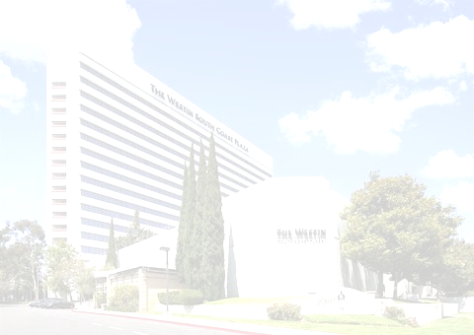
CALIFORNIA TUMOR TISSUE REGISTRY
142nd Semi-Annual Cancer Seminar

“Challenging but not Impossible: Helpful Clues for the
Daily Practice of Pancreatobiliary
Surgical and Cytopathology”

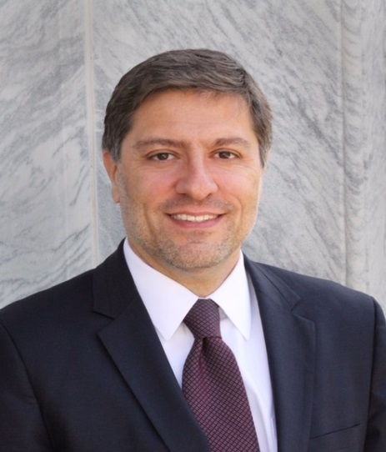
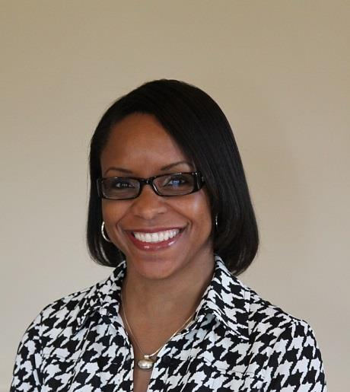
Sunday June 4, 2017
8:30 a.m. – 4:45 p.m.

Westin South Coast Plaza
686 Anton Boulevard
Costa Mesa, California 92626
Phone: (714) 540-2500
https://www.starwoodmeeting.com/Book/CTTR17

Michelle Reid, M.D., M.Sc.
Associate Professor,
Emory University

Volkan Adsay, M.D.
Professor of Pathology, Vice Chair, and Director of Anatomic Pathology
Emory University

Seminar Objectives: At the conclusion of this seminar, attendees will be able to:

- Discuss key cyto-histologic features and differential diagnosis of commonly encountered, problematic solid pancreatobiliary tract lesions.
- Review the cyto-histologic classification and reporting of cystic and intraductal pancreatobilary neoplasms, as well as benefits and limitations of ancillary testing.
- Emphasize new concepts in classification and grading of pancreatic NET’s with emphasis of morphologic repertoire and differentials.
- Review the complex periampullary region anatomy and histologic and site-specific classification of associated neoplasms with emphasis on grossing of Whipples.
- Discuss the approach to gallbladder atypia including subtle clues to diagnosis of dysplasia, recognition of tumoral intraepithelial neoplasia and invasive carcinoma.

ORDER FORM ON THE BACK ⇒
This activity has been planned and implemented in accordance with the Essential Areas and policies of the Accreditation Council for Continuing Medical Education through the joint providership of Loma Linda University School of Medicine and California Tumor and Tissue Registry. The Loma Linda University School of Medicine is accredited by the ACCME to provide continuing medical education for physicians. Loma Linda University School of Medicine designates this Live Activity and Enduring Material for a maximum of 10 AMA PRA Category 1 Credit(s) TM. Physicians should claim only the credit commensurate with the extent of their participation in the activity.
The American Board of Pathology also certifies this activity to provide up to 10 hours of SAM credit (Self Assessment Module).

