CALIFORNIA TUMOR TISSUE REGISTRY
Proudly Announces the 143rd Semi-Annual Pathology Cancer Seminar:
“Diagnostic Dilemmas in GI Pathology”
Rhonda K. Yantiss, M.D.
Chief, Gastrointestinal Pathology
Department of Pathology and Laboratory Medicine
Weill Cornell Medicine, New York, NY

Sunday December 3, 2017
8:30 a.m. – 4:45 p.m.

Hyatt Regency San Francisco
5 Embarcadero Center
San Francisco, California, 94111
https://aws.passkey.com/go/CSP2017
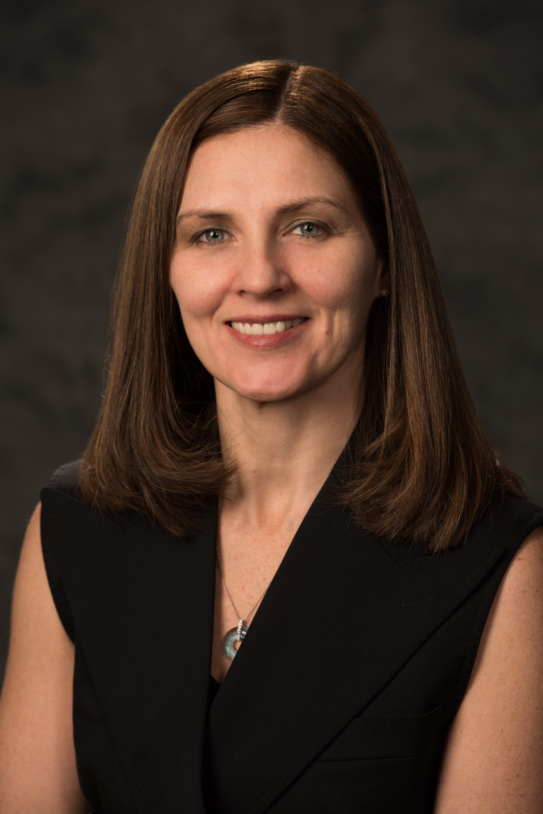


Seminar Objectives: At the conclusion of this seminar, attendees will be able to:
- Distinguish invasive adenocarcinoma from pseudoinvasion in colorectal adenomas.
- Recognize histologic clues to the presence of scant carcinoma, or sarcoma, in superficial samples.
- Formulate a differential diagnosis for “pink cell” tumors of the liver.

Materials: (“Attendance Only” includes items 1 and 2)
1. 6 hour lecture (Cover seminar objectives, correlate clinical histories, discuss the role of special studies in diagnosis, therapy,
and counseling, and project photographs of the study cases and other illustrative materials)
2. Comprehensive syllabus that includes diagnoses, discussion, and appropriate references from pertinent medical literature
3. Glass slides of representative tumors (Full package only)

CME/SAMs applies only to the day of the seminar. Full Package can earn up to 10 hrs CME and/or SAM, Attendance only can earn up to 6 hrs CME/SAM. This activity is approved for a maximum of 10 SAM credits. Accreditation Statement: Loma Linda School of Medicine is accredited by the Accreditation Council for Continuing medical education for physicians. Loma Linda University School of Medicine designates this live activity and enduring material for a maximum of 10 AMA PRA Category 1 Credit(s) TM. Physicians should claim only the credit commensurate with the extent of their participation in the activity. Disclosure Statement: This program has been planned and implemented in accordance with ACCME essentials and standards. The Loma Linda School of Medicine Office of Continuing Medical Education relies on its CME faculty to provide program content that is free of commercial bias. Therefore, in accordance with ACCME standards, any faculty and/or provider industry relationships will be disclosed and resolved.

REGISTRATION FEE | Early Bird by 10/23/17 | After 10/23/17
Full Package: Up to 10 CME/SAMs credit  Includes: Glass slides and/or digital slides, Attendance & Syllabus. Must attend the seminar & send in answers before 12/3/17 for full credit.  Full Package: NO CME/SAMs credit  Includes: Glass slides and/or digital slides, Attendance & Syllabus.  Resident Package: NO CME/SAMs credit  Includes: Attendance & Syllabus. ** With a letter verifying residency/fellowship status  Attendance Only: Up to 6 CME/SAMs credit  Includes: Attendance & Syllabus.  Attendance Only: NO CME/SAMs credit  Includes: Attendance & Syllabus.  Resident Attendance Only: NO CME/SAMs credit  Includes: Attendance & Syllabus. **With a letter verifying residency/fellowship status | $350.00  $300.00  $225.00  $275.00  $225.00  $175.00 | $400.00  $350.00  $300.00  $300.00  $250.00  $175.00
+ Cancellations subject to a 15% overhead charge * For orders outside the United States of America, please add $45.00
Registration Form: (complete & mail, fax, or call CTTR)
Please Circle: Check (mail) Visa Master Card
Name on Card:
Credit Card number:
Expiration Date: Zip code of billing address:
Total Amount:

Name:
Facility:
Address:
City, State, Country:
Zip: Phone:
Email:

Signature for Credit Card Authorization:
Mail Registration Form To: California Tumor Tissue Registry, 11021 Campus Street, AH 335, Loma Linda, CA 92350
Phone: (909) 558-4788 / Fax: (909) 558-0188 email: cttr@llu.edu

